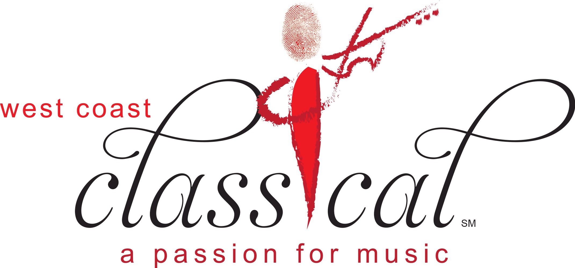 West Coast Classical
ORDER FORM FOR PROGRAM ADS
EIN #46-3286923

CONTACT NAME PHONE

COMPANY NAME PHONE

COMPANY ADDRESS

CITY STATE ZIP

EMAIL

__________________________________________________________________________
ORCHESTRA MEMBER CONTACT

Please attach business card or copy of your ad in the size you prefer. The ad must be camera-ready and sized to fit the space selected.

Please make checks payable to West Coast Classical, and mail to P.O. Box 449, Acton, CA 93510, or give to any member or Board member. West Coast Classical is a 501(c) non-profit organization.

For further information, please email debbie.barrientes@westcoastclassical.org

ADS ARE DUE NO LATER THAN DECEMBER 3, 2025

Single Program Ad Prices: (December 20,21)

____Business Card ($75) ___ ¼ page ($125) ____1/2 page ($200) ____Full page($325)

2023-24 Seasonal Program Ad Prices:

_____Business Card ($195)_____1/4 page ($325)_____1/2 page ($530)_____Full page ($870)

Please see our website for the dates of the 2025-2026 Concerts: www.westcoastclassical.org

